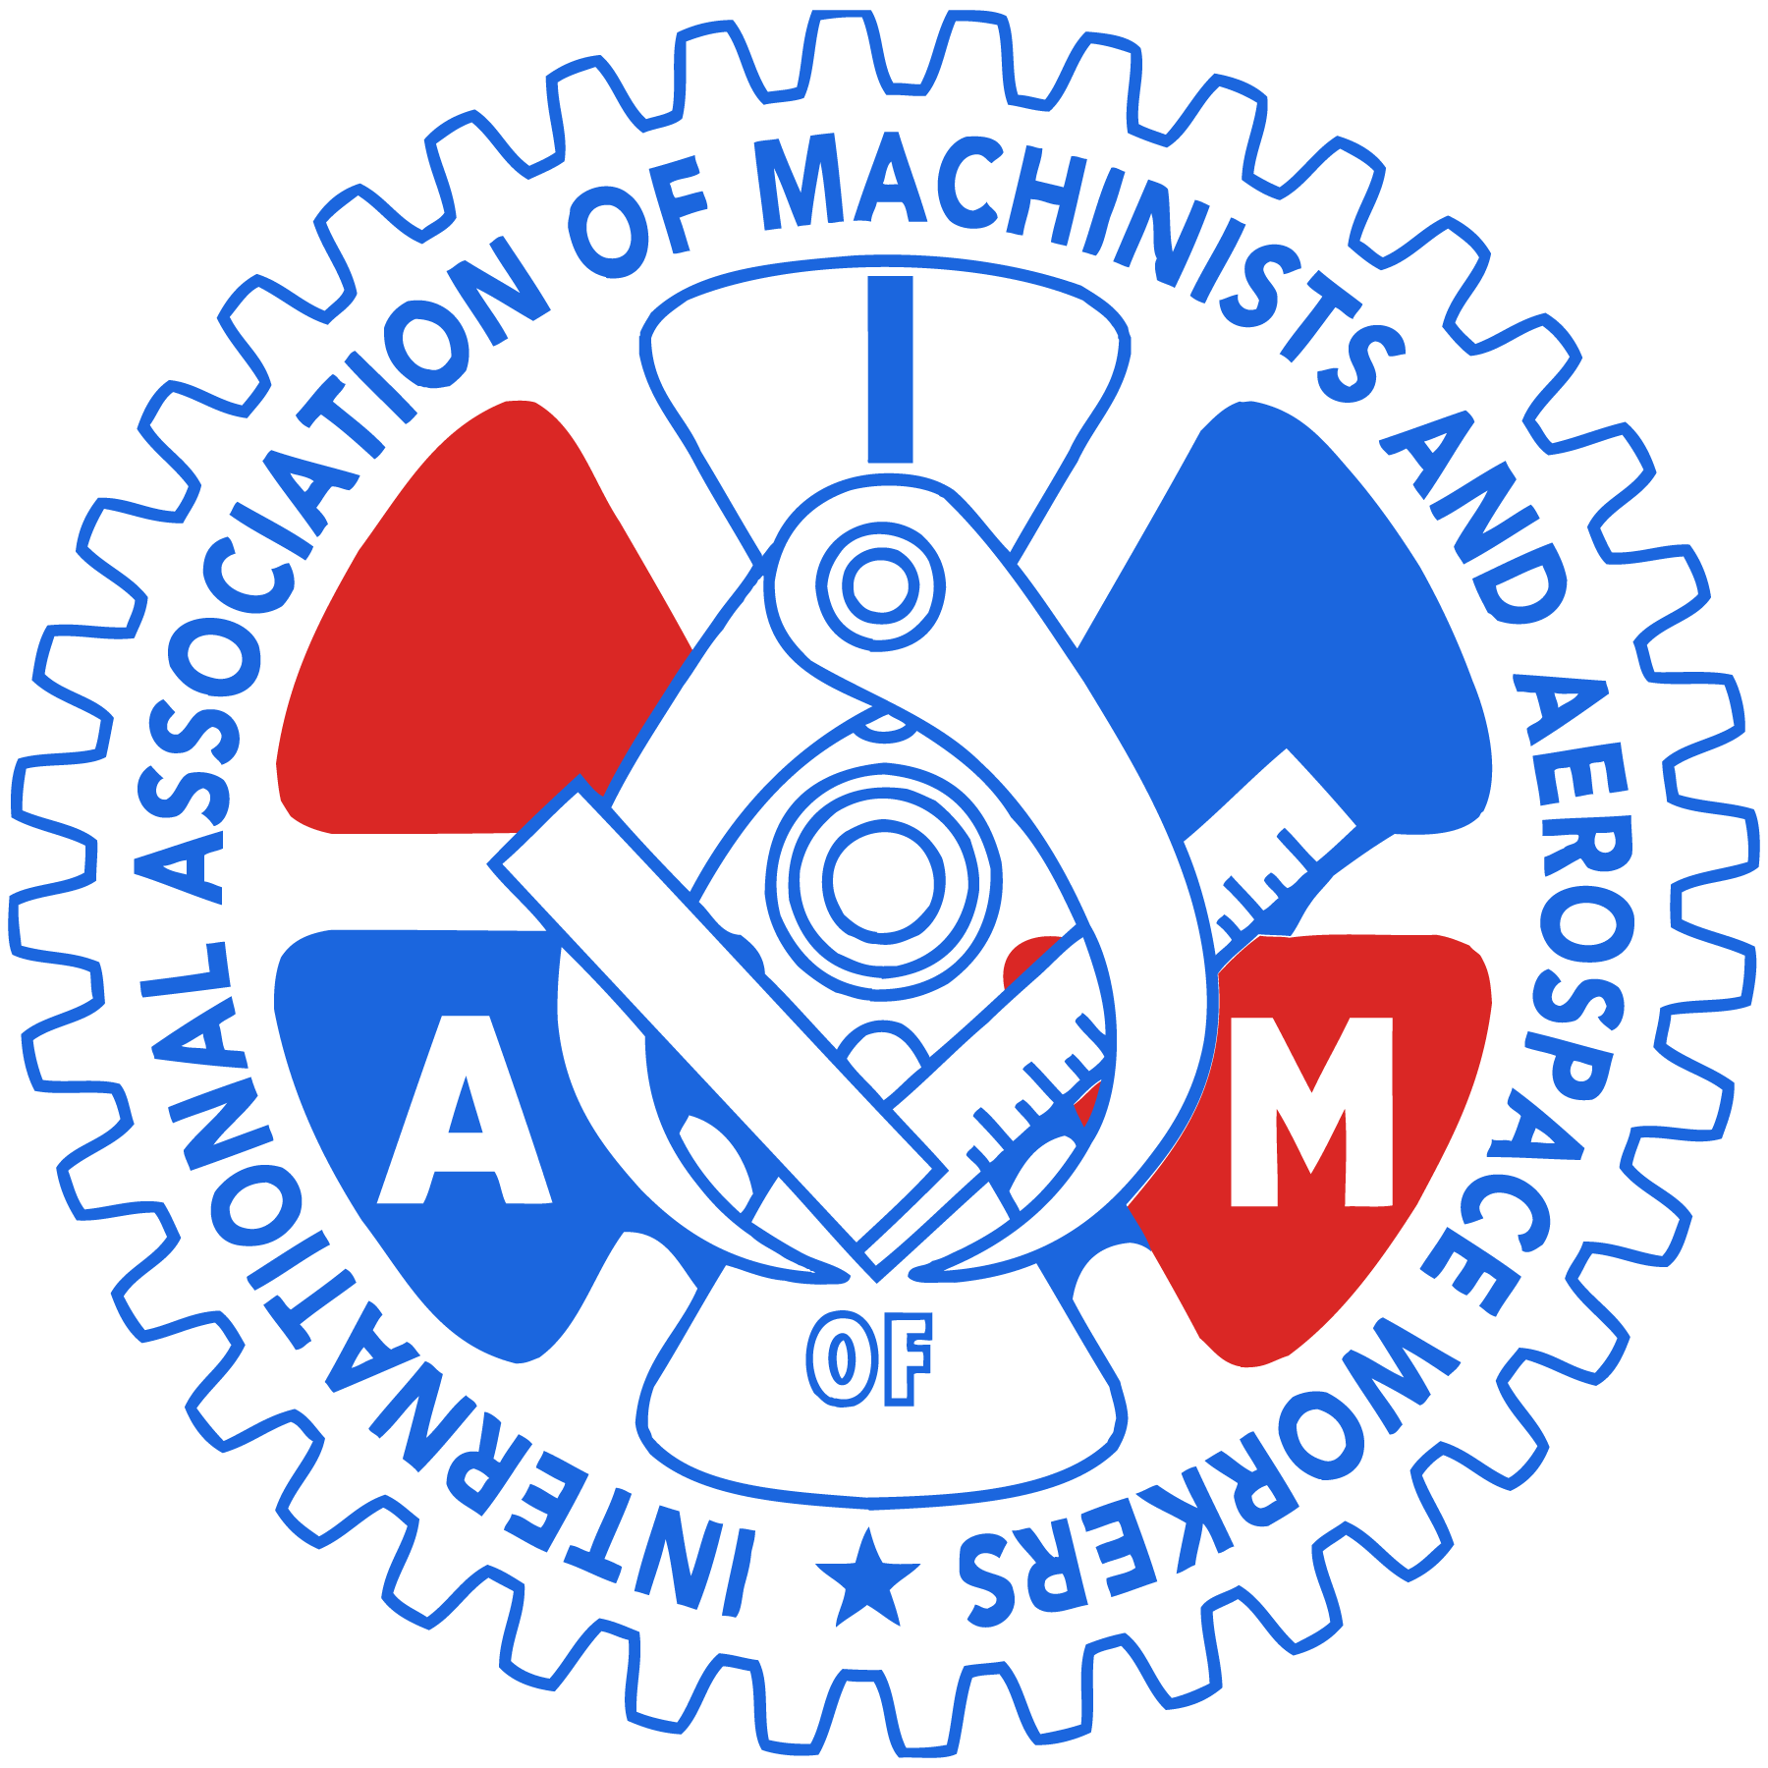

Nominations for the December 5, 2019 Officer and Committee Election
Cleveland Air Transport Local Lodge 1731
International Association of Machinists and Aerospace Workers

The following members received nominations for office at the regular meeting of the lodge on November 7, 2019. *** All nominations are unopposed therefore there will not be an election on December 5, 2019. *** Members on this list will take office on January 2, 2020 for a three year term

Vacancies for Recording Secretary, two Auditors, Southwest Committees will be appointed by the new President with approval of the executive board after January 2, 2020.

President Joe LaNasa
Vice President Jason Bradley
Recording Secretary Vacant
Secretary Treasurer John Altmeyer
Trustee Jamie Johnson
Trustee Ron Hovanec
Trustee Karen Schultz
Conductor Sentinel Kathy Pachuta
Auditor John Cawley
Auditor Vacant
Auditor Vacant

United Committee Chair Joe LaNasa
United Committee Ramp Jason Bradley
United Committee Customer Service Kathy Pachuta
United Committee Stores Kevin Baker
Southwest Committee Chair Vacant
Southwest Committee Columbus Vacant
Southwest Committee Cleveland Vacant

Dean Franklin
Recording Secretary
IAMAW Local Lodge 1731

