WHO: | Ohio Means Jobs  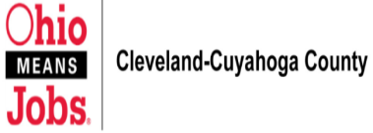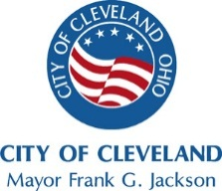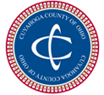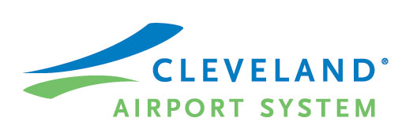  Presents  Job Fair
WHAT: | Ohio Means Jobs formerly Employment Connection is hosting a JOB FAIR on behalf of the employees of United Airlines & Chelsea Food Services:  Thursday ~ May 1, 2014  10:00am to 3:00pm  CTC Building  5900 Cargo Road  Cleveland, Ohio 44135  On-site Parking Available
Participating Organizations: | Orlando Baking AT-F  The 9 Metropolitan Hotel RTA  Vocalink Giant Eagle/Seaway  Dollar General United Consumer  Barden Circulation Cleveland Indians  Dwellworks Terminix  Holiday Inn Double Tree Hotel  Safety Controls Tech CRS Marketing  Rocksino The Travel Connection  Lowes Fedex  Advantage Sales & Marketing  Cuyahoga County Executive Office

